For Immediate Release:
Contact: Jo-Ann Dean, SIGNmation
broadwaysigns.asl@gmail.com
(310) 467-3220

BROADWAY SIGNs! HOSTS FUNDRAISER FOR DEAF AUSTIN THEATRE’S THE LARAMIE PROJECT

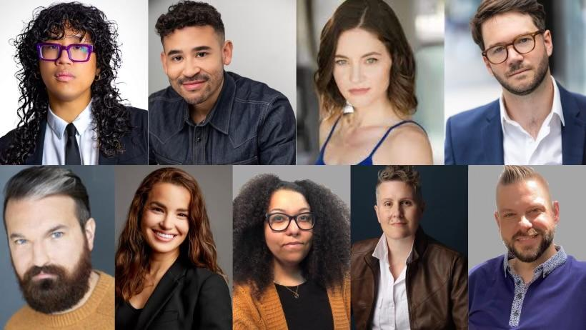

NYC: Join BROADWAY SIGNs! PRIDE at Triad Theater Broadway’s Sandra Mae Frank (Deaf West Spring Awakening Revival, NBC’s New Amsterdam and Co-Host Joey Antonio (Dance Camp, Zoe’s Extraordinary Play List) leading a stellar cabaret of American Sign Language (ASL) Poetry & Broadway Hits from Rent, La Cage Aux Folles and more performed by Deaf Artists! All ticket proceeds benefit Deaf Austin Theatre’s (DAT) fall production of The Laramie Project, written by Moises Kaufman and Tectonic Theater Project. The one-night only gala debuts Thursday, August 3rd from 7-9 pm at the Triad Theatre! Click here for tickets. https://tinyurl.com/5eev489y

Broadway SIGNs! PRIDE will also be streamed via Stellar Livestream Link: https://tinyurl.com/u5p7tkp3

Featuring members from Deaf Broadway’s Company at Lincoln Center Joey Caverly (Hulu’s Only Murders in the Building), Dickie Hearts (Public’s Dark Disabled Stories), Heba Toulan (DAT & ZACH Theatre’s Rogers and Hammersteins Cinderella), Kailyn Aaron-Lozano (DAT & ZACH Theater’s Rogers and Hammersteins Cinderella), Jules Dameron (Director, The Laramie Project) and Andrew Morrill (Broadway’s Grey House). Guest performances by Erin Rosenfeld (Broadway’s Grey House), CoHosts Sandra Mae Frank, Joey Antonio and Brian Cheslik add to Broadway revue of songs!

Special Guest Barbara Pitt McAdams Tectonic Theater Writer, an original cast member of The Laramie Project along with DAT’s Artistic Director Dr. Brian Cheslik and Director Jules Dameron kick off cultural pride and honor the life and legacy of Matthew Shepard.

The cast will perform in American Sign Language (ASL) excerpts from the critically acclaimed Stonewall Honor Book October Mourning: A Song for Matthew Shepard, written by Leslea Newman. Featuring Christian Brailsford (Pretty Woman) reading the prose in Spoken English. Offering a powerful visual prelude to Deaf Austin Theatre’s ASL production of The Laramie Project.

A Silent Auction is available to all participant.
Link: https://givebutter.com/c/LaramieASL

All Performances are in American Sign Language & Spoken English. Music Director & Pianist Kevin Winebold, Disney Theatrical Group. Stage Manager Miriam Rochford. Production Assistant Katie Lloyd. ASL Interpretation by Zak Taylor and Alberto Medero. Produced by Jo-Ann Dean, SIGNmation.

SIGNmation promotes Deaf Artists & American Sign Language and culturally accessible content for the Arts, producing the hit cabaret show Broadway SIGNs!
Review: If These Hands Could Talk @54Below https://tinyurl.com/57jjnvhd
Upcoming Broadway SIGNs! returns Halloween night, pumpkins out! We’re back!

The Laramie Project is a thought-provoking documentary play that explores the aftermath of the tragic 1998 murder of Matthew Shepard, a young gay college student in Laramie, Wyoming. The play delves into the impact of the incident on the local community and raises important questions about prejudice, hate crimes and tolerance. DAT aims to promote inclusivity, accessibility, and awareness of these same experiences faced by the Deaf and LGBTQIA communities.
Deaf Austin Theatre’s production of The Laramie Project is funded in part by National Endowment for the Arts, Greater Austin Foundation for the Deaf, Matthew Shepard Foundation, BEA Investment Group, Ploeger ASL Interpreting, LLC; Dozanu Innovation, National Disability Theatre, Communication By Hand, Sorenson, True+Way ASL, Hypernovas Productions and SIGNmation. Marking the first professional production of the play ever produced in American Sign Language (ASL).
https://tinyurl.com/4hvr3hbd

To learn more about Deaf Austin Theatre's production of The Laramie Project, please visit www.deafaustintheatre.org and
https://donorbox.org/the-laramie-project-2#info

www.SIGNmation.com
Facebook: broadwaysignsasl
Instagram: @broadwaysignsasl
Poster:
